**Report For Runlinc**

**(A case study for Robot Camera View)**

By

Afolayan Oluwatimilehin Israel

080-452

BSE(Software Engineering)

**Introduction**

This project teaches you how to include vision in your runlinc projects by live-streaming a video from your phone’s camera or any other IP camera that can connect to WIFI and stream it to runlinc.

Streaming is the idea or method of transmitting and/or receiving data continuously over a network. Streaming is used in many applications with the most notable being multimedia. This is due to multimedia requiring a large amount of data for a computer to play the media. But then, you might think, isn’t downloading and streaming the same thing? They are similar indeed, but one significant difference is that downloading requires you to have the file first downloaded into your device’s memory or storage before the file can be used which in many cases will take up a significant amount of storage on your device. Whereas streaming does not need to store the files in their entirety, it breaks the files into small chunks which are downloaded, viewed and then deleted once they aren’t needed anymore. This also speeds up the viewing as the start of the media can be viewed while later portions are still being downloaded. This can have implications for devices with small memory. Video files can often have megabytes of data for a few seconds of recording, devices such as runlinc on STEMSEL with only a small amount of flash memory, streaming is necessary. But the downside of streaming is that since the data is not stored, the data must be streamed again if it is required a second time. Cameras can be used remotely by streaming data to a host. In this project, we’ll utilise this application to turn a camera into a remote camera. Camera streaming has security and safety applications such as checking your home when a sensor has sensed someone is in the house when you are not there; and with digital processing, it has applications in AI and robotics like image recognition.

**Visual Content**

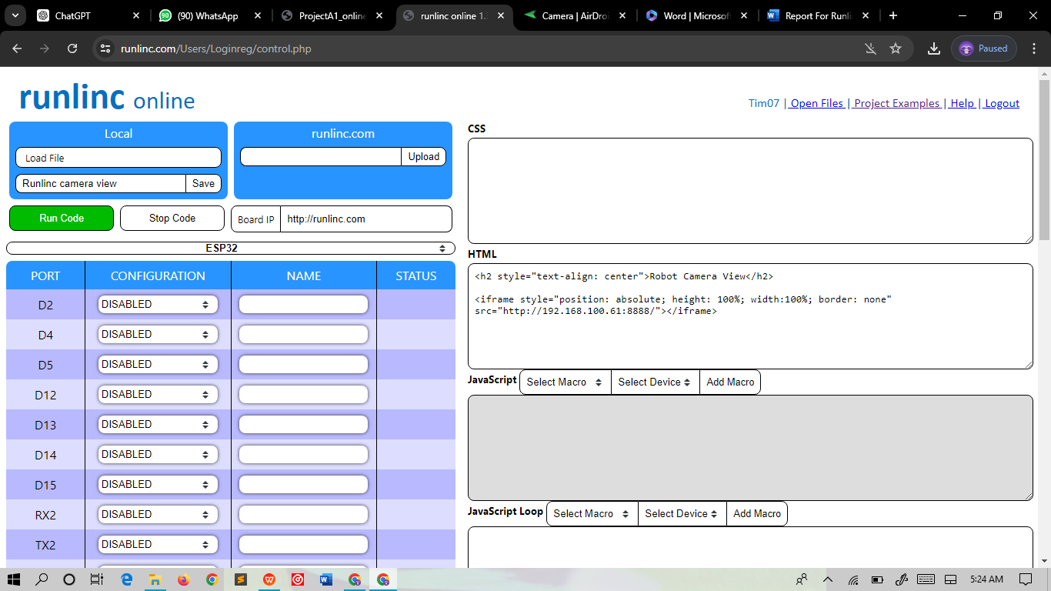

**Rare view of the camera**

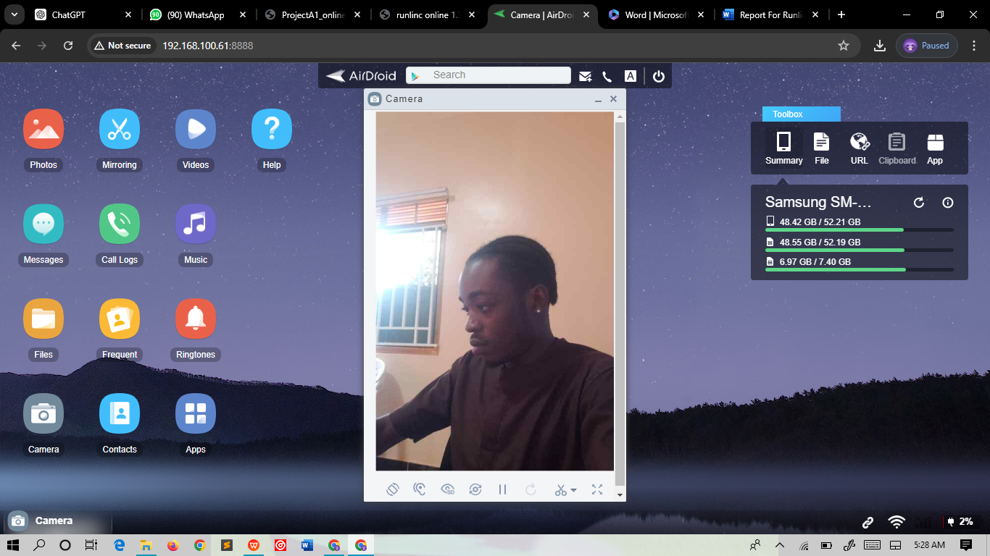

**Back view of the camera**

